UNITED STATES
SECURITIES AND EXCHANGE COMMISSION
Washington, D.C. 20549
FORM 8-K
CURRENT REPORT
PURSUANT TO SECTION 13 OR 15(d) OF THE
SECURITIES EXCHANGE ACT OF 1934
Date of Report (Date of earliest event reported): July 28, 2026
ALKERMES PUBLIC LIMITED COMPANY
(Exact name of registrant as specified in its charter)

Ireland |  | 001-35299 |  |  |  | 98-1007018
(State or other jurisdiction |  | (Commission |  |  |  | (IRS Employer
of incorporation) |  | File Number) |  |  |  | Identification No.)
Connaught House, 1 Burlington Road
Dublin 4, Ireland D04 C5Y6
(Address of principal executive offices)

Registrant's telephone number, including area code: + 353-1-772-8000
Check the appropriate box below if the Form 8-K filing is intended to simultaneously satisfy the filing obligation of the registrant under any of the following provisions (see General Instruction A.2. below):

☐ |  | Written communications pursuant to Rule 425 under the Securities Act (17 CFR 230.425)
☐ |  | Soliciting material pursuant to Rule 14a-12 under the Exchange Act (17 CFR 240.14a-12)
☐ |  | Pre-commencement communications pursuant to Rule 14d-2(b) under the Exchange Act (17 CFR 240.14d-2(b))
☐ |  | Pre-commencement communications pursuant to Rule 13e-4(c) under the Exchange Act (17 CFR 240.13e-4(c))

Securities registered pursuant to Section 12(b) of the Act:
Title of each class |  | Trading Symbol(s) |  | Name of each exchange on which registered
Ordinary shares, $0.01 par value |  | ALKS |  | Nasdaq Global Select Market

Indicate by check mark whether the registrant is an emerging growth company as defined in Rule 405 of the Securities Act of 1933 (§230.405 of this chapter) or Rule 12b-2 of the Securities Exchange Act of 1934 (§240.12b-2 of this chapter).

Emerging growth company ☐

If an emerging growth company, indicate by check mark if the registrant has elected not to use the extended transition period for complying with any new or revised financial accounting standards provided pursuant to Section 13(a) of the Exchange Act. ☐

Item 2.02 Results of Operations and Financial Condition.

On July 28, 2026, Alkermes plc (the “Company”) announced financial results for the three and six months ended June 30, 2026 and updated certain financial expectations for the year ending December 31, 2026. Copies of the related press release and the investor presentation to be displayed during the Company’s conference call on July 28, 2026 discussing such financial results and expectations are furnished herewith as Exhibit 99.1 and Exhibit 99.2, respectively. This information, including Exhibits 99.1 and 99.2, shall not be deemed “filed” for purposes of Section 18 of the Securities Exchange Act of 1934, as amended (the “Exchange Act”), or incorporated by reference in any filing under the Securities Act of 1933, as amended, or the Exchange Act, except as shall be expressly set forth by specific reference in such a filing.

Item 9.01 Financial Statements and Exhibits.
(d) Exhibits

EXHIBIT INDEX

Exhibit No. |  | Description
99.1 |  | Press release issued by Alkermes plc on July 28, 2026 announcing financial results for the three and six months ended June 30, 2026 and financial expectations for the year ending December 31, 2026.
99.2 |  | Investor presentation to be displayed by Alkermes plc on July 28, 2026.
104 |  | Cover page interactive data file (embedded within the Inline XBRL document).

2

SIGNATURE
Pursuant to the requirements of the Securities Exchange Act of 1934, the registrant has duly caused this report to be signed on its behalf by the undersigned hereunto duly authorized.

 | ALKERMES PLC
Date: July 28, 2026 | By: |  | /s/ Joshua Reed
 |  |  | Joshua Reed
 |  |  | Senior Vice President, Chief Financial Officer (Principal Financial Officer)

3

Exhibit 99.1
 | Alkermes Contacts:
 | For Investors: | Sandy Coombs +1 781 609 6377
 | For Media: | Katie Joyce +1 781 249 8927

Alkermes plc Reports Second Quarter 2026 Financial Results
— Second Quarter Revenues of $496.0 Million —
— GAAP Net Income of $0.5 Million and Adjusted EBITDA of $139.2 Million —
— Blair Jackson to Assume Chief Executive Officer Role on August 1, 2026; Richard Pops to Continue as Chairman of the Board of Directors —

DUBLIN, July 28, 2026 — Alkermes plc (Nasdaq: ALKS) today reported financial results for the second quarter of 2026.

“The second quarter was marked by strong commercial performance and meaningful progress across our pipeline as we continued to execute on our strategic priorities. Our commercial portfolio consists of differentiated products that are positioned to generate substantial revenue and cash flow for years to come. At the same time, our orexin 2 receptor agonist portfolio represents a potentially transformational growth opportunity for Alkermes and positions us at the forefront of one of the most exciting new therapeutic categories in neuroscience,” said Richard Pops, Chairman and Chief Executive Officer of Alkermes. “As I prepare to transition the Chief Executive Officer role, I do so with tremendous pride in what this organization has achieved and great optimism for its future. Blair and the leadership team are well positioned to build on this momentum and lead Alkermes through its next phase of growth, innovation and value creation, and I look forward to supporting them in my continuing role as Chairman.”

“As we move into the second half of the year, we have clear priorities and a sharp focus on execution. With our first ADHD data for ALKS 7290 expected in the coming months and topline results from our alixorexton phase 2 idiopathic hypersomnia study expected toward year-end, we are generating significant new datasets that may open new opportunities for our orexin 2 receptor portfolio,” said Blair Jackson, Chief Operating Officer of Alkermes. “With a talented team, a strong financial foundation and exciting opportunities ahead in sleep medicine and across our neuroscience portfolio, I am honored to step into the CEO role and continue building on the strong foundation for growth that Richard and the entire organization have established.”

Key Financial Highlights
Revenues
 | Three Months Ended  June 30, |  |  |  |  | Six Months Ended  June 30,
(In millions) | 2026 |  | 2025 |  |  | 2026 |  | 2025
Total Revenues | $ | 496.0 | $ | 390.7 |  | $ | 888.9 | $ | 697.2
Total Proprietary Net Sales | $ | 411.7 | $ | 307.2 |  | $ | 749.8 | $ | 551.7
VIVITROL® | $ | 124.5 | $ | 121.7 |  | $ | 236.9 | $ | 222.7
ARISTADA®i | $ | 96.7 | $ | 101.3 |  | $ | 190.5 | $ | 174.8
LYBALVI® | $ | 94.0 | $ | 84.3 |  | $ | 186.3 | $ | 154.3
LUMRYZ® | $ | 96.6 | $ | — |  | $ | 136.1 | $ | —
Profitability
 | Three Months Ended  June 30, |  |  |  |  | Six Months Ended  June 30,
(In millions) | 2026 |  | 2025 |  |  | 2026 |  | 2025
GAAP Net (Loss) Income | $ | 0.5 | $ | 87.1 |  | $ | (66.0) | $ | 109.6
EBITDA | $ | 49.0 | $ | 101.6 |  | $ | 18.8 | $ | 124.3
Adjusted EBITDA | $ | 139.2 | $ | 126.5 |  | $ | 219.5 | $ | 172.1

1

Revenue Highlights
Proprietary Product Revenues
•
LYBALVI revenues for the quarter were $94.0 million. Revenues and total prescriptions grew 12% and 18%, respectively, compared to the second quarter of 2025.
•
ARISTADAi revenues for the quarter were $96.7 million. During the quarter, the company recorded ARISTADA revenue of approximately $4 million related to gross-to-net favorability, primarily driven by favorable patient mix.
•
VIVITROL revenues for the quarter were $124.5 million. During the quarter, the company recorded VIVITROL revenue of approximately $4 million related to gross-to-net favorability, primarily driven by favorable patient mix.
•
LUMRYZ revenues for the quarter were $96.6 million, which included approximately $7 million of inventory benefit due to timing of shipments.
Manufacturing & Royalty Revenues
•
VUMERITY® manufacturing and royalty revenues for the quarter were $30.6 million.
•
Royalty revenue from XEPLION®, INVEGA TRINZA®/TREVICTA® and INVEGA HAFYERA®/BYANNLI® for the quarter were $27.5 million.
•
Manufacturing revenue from RISPERDAL CONSTA® for the quarter was $20.9 million.

Key Operating Expenses

Three Months Ended
June 30,
(In millions) | 2026  GAAP |  | 2026  Transaction Adjustments |  | 2026  Non-GAAP  Adjusted |  | 2025  GAAP
Cost of Goods Sold | $ | 98.1 | $ | 31.0 | $ | 67.1 | $ | 49.5
R&D Expense | $ | 112.9 | $ | 0.1 | $ | 112.8 | $ | 77.4
SG&A Expense | $ | 217.6 | $ | 1.3 | $ | 216.3 | $ | 170.8

Six Months Ended
June 30,
(In millions) | 2026  GAAP |  | 2026  Transaction Adjustments(1) |  | 2026  Non-GAAP  Adjusted |  | 2025  GAAP
Cost of Goods Sold | $ | 159.7 | $ | 43.8 | $ | 115.9 | $ | 98.7
R&D Expense | $ | 216.3 | $ | 8.2 | $ | 208.1 | $ | 149.2
SG&A Expense | $ | 482.2 | $ | 56.6 | $ | 425.6 | $ | 342.6

(1)
Includes $20.2 million of share-based compensation expense related to the acceleration of vesting of equity awards for former Avadel Pharmaceuticals plc (Avadel) employees which vested in full upon the closing of the transaction.
•
During the quarter, the company recorded a change in the fair value of contingent consideration of $26.4 million, related to the CVR milestone associated with the acquisition of Avadel, which was deemed more likely to be achieved following the recently announced positive topline results of the phase 3 study of LUMRYZ in idiopathic hypersomnia.

Balance Sheet
•
At June 30, 2026, the company recorded cash, cash equivalents and total investments of $691.6 million, compared to $538.2 million at March 31, 2026.

2

Financial Expectations for 2026
All line items are according to GAAP, except as otherwise noted.

(In millions) |  | Previous 2026 Expectations  (provided May 5, 2026) |  | Updated 2026 Expectations  (provided July 28, 2026)
Total Revenues |  | $1,730 – $1,840 |  | $1,730 – $1,840
VIVITROL Net Sales |  | $460 – $480 |  | $460 – $480
LYBALVI Net Sales |  | $380 – $400 |  | $380 – $400
ARISTADAi Net Sales |  | $365 – $385 |  | $365 – $385
LUMRYZ Net Sales a |  | $315 – $335 |  | $315 – $335
Cost of Goods Sold b |  | $320 – $340 |  | $320 – $340
R&D Expenses |  | $445 – $485 |  | $445 – $485
SG&A Expenses |  | $890 – $930 |  | $890 – $930
Amortization of Intangible Assets c |  | $75 – $85 |  | $75 – $85
Change in the Fair Value of Contingent Consideration d |  | — |  | ~$25
Net Interest Expense |  | $75 – $85 |  | $75 – $85
Net Tax Benefit |  | ~$0 |  | ~$0
GAAP Net Loss e |  | ($70) – ($90) |  | ($95) – ($115)
EBITDA f |  | $105 – $135 |  | $75 – $95
Adjusted EBITDA f |  | $370 – $410 |  | $370 – $410

a | The acquisition of Avadel closed on Feb. 12, 2026. LUMRYZ Net Sales expectations represents the period of Feb. 12, 2026 – Dec. 31, 2026.
b | In connection with the acquisition of Avadel, the company will record approximately $125 million of LUMRYZ inventory fair value step-up; the company expects that approximately $105 million of this amount will be expensed in 2026 as this inventory is sold.
c | In connection with the acquisition of Avadel, the company expects to record approximately $1.8 billion of intellectual property related to LUMRYZ, which will be amortized over an expected life of 14 years.
d | In connection with the positive topline results of the LUMRYZ phase 3 study in idiopathic hypersomnia, the company recorded an increase of $26.4 million in the fair value of contingent consideration related to the Avadel acquisition contingent value right (CVR) milestone.
e | Expected 2026 weighted average basic share count of approximately 169.1 million shares outstanding and a weighted average diluted share count of approximately 172.8 million shares outstanding.
f | Non-GAAP measure.

Conference Call
Alkermes will host a conference call and webcast presentation with accompanying slides at 8:00 a.m. ET (1:00 p.m. BST) on Tuesday, July 28, 2026, to discuss these financial results and expectations and provide an update on the company. The webcast may be accessed on the Investors section of Alkermes’ website at www.alkermes.com. The conference call may be accessed by dialing +1 877 407 2988 for U.S. callers and +1 201 389 0923 for international callers. In addition, a replay of the conference call may be accessed by visiting Alkermes’ website.

About Alkermes plc
Alkermes plc, a mid-cap growth and value equity, is a global biopharmaceutical company that seeks to develop innovative medicines in the field of neuroscience. The company has a portfolio of proprietary commercial products for the treatment of alcohol dependence, opioid dependence, schizophrenia, bipolar I disorder and narcolepsy. Alkermes’ pipeline includes late-stage clinical candidates in development for narcolepsy and idiopathic hypersomnia, and orexin 2 receptor agonists in early clinical development for other neurological disorders, including attention-deficit hyperactivity disorder (ADHD) and fatigue associated with multiple sclerosis and Parkinson’s disease. Headquartered in Ireland, Alkermes also has a corporate office and research and development center in Massachusetts and a manufacturing facility in Ohio. For more information, please visit Alkermes’ website at www.alkermes.com.

3

Non-GAAP Financial Measures
This press release includes information about certain financial measures that are not prepared in accordance with generally accepted accounting principles in the U.S. (GAAP), including EBITDA and Adjusted EBITDA. These non-GAAP measures are not based on any standardized methodology prescribed by GAAP and are not necessarily comparable to similar measures presented by other companies.

EBITDA represents earnings before interest, tax, depreciation and amortization. Adjusted EBITDA excludes share-based compensation expense and non-recurring gains or losses in addition to the components of EBITDA from earnings.

The company’s management and board of directors utilize these non-GAAP financial measures to evaluate the company’s performance. The company provides these non-GAAP financial measures of the company’s performance to investors because management believes that these non-GAAP financial measures, when viewed with the company’s results under GAAP and the accompanying reconciliations, are useful in identifying underlying trends in ongoing operations. However, EBITDA and Adjusted EBITDA are not measures of financial performance under GAAP and, accordingly, should not be considered as alternatives to GAAP measures as indicators of operating performance. Further, EBITDA and Adjusted EBITDA should not be considered measures of the company’s liquidity.
A reconciliation of GAAP to non-GAAP financial measures has been provided in the tables included in this press release.

Note Regarding Forward-Looking Statements
Certain statements set forth in this press release constitute “forward-looking statements” within the meaning of the Private Securities Litigation Reform Act of 1995, as amended, including, but not limited to, statements concerning: the company’s expectations concerning its future financial and operating performance, business plans or prospects, including expectations related to revenue, growth, profitability and value creation; and expectations regarding development timelines for, and the potential therapeutic and commercial value of, alixorexton and the company’s other development candidates. The company cautions that forward-looking statements are inherently uncertain. The forward-looking statements are neither promises nor guarantees and they are necessarily subject to a high degree of uncertainty and risk. Actual performance and results may differ materially from those expressed or implied in the forward-looking statements due to various risks and uncertainties. These risks and uncertainties include, among others: the company may not be able to achieve its financial expectations, including those related to revenue, growth, profitability and value creation; clinical development activities may not be completed on time or at all; the results of the company’s development activities may not be positive, or predictive of final results from such activities, results of future development activities or real-world results; the unfavorable outcome of arbitration, litigation, or other proceedings or disputes related to the company’s products or products using the company’s proprietary technologies; the company’s products or product candidates could be shown to be ineffective or unsafe; the U.S. Food and Drug Administration or regulatory authorities outside the U.S. may not agree with the company’s regulatory approval strategies or components of its development programs and may make adverse decisions regarding the company’s products; the company and its licensees may not be able to continue to successfully commercialize their products or support revenue growth from such products; potential changes in the competitive landscape impacting our products, including earlier than anticipated entry of competition from generic forms of our products or competitive products and negotiated maximum fair pricing of competitive products; potential changes in the cost, scope and duration of the company’s development programs; the businesses of Alkermes and Avadel may not be effectively integrated and the expected benefits and value of the acquisition may not be achieved; there may be unknown or inestimable liabilities and potential litigation associated with the acquisition; there may be a reduction in payment rate or reimbursement for the company’s products or an increase in the company’s financial obligations to government payers; the company’s products may prove difficult to manufacture, be precluded from commercialization by the proprietary rights of third parties, or have unintended side effects, adverse reactions or incidents of misuse; and those risks and uncertainties described under the heading “Risk Factors” in the company’s Annual Report on Form 10-K for the year ended Dec. 31, 2025 and in subsequent filings made by the company with the U.S. Securities and Exchange Commission
4

(SEC), which are available on the SEC’s website at www.sec.gov. Existing and prospective investors are cautioned not to place undue reliance on these forward-looking statements, which speak only as of the date hereof. Except as required by law, the company disclaims any intention or responsibility for updating or revising any forward-looking statements contained in this press release.

VIVITROL® is a registered trademark of Alkermes, Inc.; ARISTADA®, ARISTADA INITIO® and LYBALVI® are registered trademarks of Alkermes Pharma Ireland Limited, used by Alkermes, Inc. under license; LUMRYZ® is a registered trademark of Flamel Ireland Limited, an affiliate of Alkermes plc; BYANNLI®, INVEGA HAFYERA®, INVEGA TRINZA®, TREVICTA®, XEPLION® and RISPERDAL CONSTA®, are registered trademarks of Johnson & Johnson or its affiliated companies; and VUMERITY® is a registered trademark of Biogen MA Inc., used by Alkermes under license.

(tables follow)

i | The term “ARISTADA” as used in this press release refers to ARISTADA and ARISTADA INITIO®, unless the context indicates otherwise.

5

Alkermes plc and Subsidiaries
Selected Financial Information (Unaudited)
Condensed Consolidated Statements of Operations - GAAP |  | Three Months Ended |  |  |  | Three Months Ended
(In thousands, except per share data) |  | June 30, 2026 |  |  |  | June 30, 2025
Revenues:
Product sales, net |  | $ | 411,724 |  |  | $ | 307,235
Manufacturing and royalty revenues |  |  | 84,285 |  |  |  | 83,422
Total Revenues |  |  | 496,009 |  |  |  | 390,657
Expenses:
Cost of goods manufactured and sold |  |  | 98,112 |  |  |  | 49,460
Research and development |  |  | 112,920 |  |  |  | 77,370
Selling, general and administrative |  |  | 217,625 |  |  |  | 170,849
Amortization of acquired intangible assets |  |  | 22,585 |  |  |  | —
Change in the fair value of contingent consideration |  |  | 26,414 |  |  |  | —
Total Expenses |  |  | 477,656 |  |  |  | 297,679
Operating Income |  |  | 18,353 |  |  |  | 92,978
Other (Expense) Income, net:
Interest income |  |  | 5,344 |  |  |  | 11,090
Interest expense |  |  | (25,925 | ) |  |  | —
Other income, net |  |  | 352 |  |  |  | 771
Total Other (Expense) Income, net |  |  | (20,229 | ) |  |  | 11,861
(Loss) Income Before Income Taxes |  |  | (1,876 | ) |  |  | 104,839
Income Tax (Benefit) Provision |  |  | (2,377 | ) |  |  | 17,741
Net Income — GAAP |  | $ | 501 |  |  | $ | 87,098
Earnings Per Share - Basic |  | $ | 0.00 |  |  | $ | 0.53
Earnings Per Share - Diluted |  | $ | 0.00 |  |  | $ | 0.52
Weighted Average Number of Ordinary Shares Outstanding:
Basic |  |  | 167,026 |  |  |  | 164,959
Diluted |  |  | 173,478 |  |  |  | 168,357
An itemized reconciliation between net income on a GAAP basis and Adjusted EBITDA is as follows:
Net Income — GAAP |  | $ | 501 |  |  | $ | 87,098
Adjustments:
Interest income |  |  | (5,344 | ) |  |  | (11,090 | )
Interest expense |  |  | 25,925 |  |  |  | —
Income tax provision |  |  | (2,377 | ) |  |  | 17,741
Depreciation expense |  |  | 7,693 |  |  |  | 7,818
Amortization of acquired intangible assets |  |  | 22,585 |  |  |  | —
EBITDA |  |  | 48,983 |  |  |  | 101,567
Share-based compensation |  |  | 31,296 |  |  |  | 24,966
Costs related to the acquisition of Avadel |  |  | 32,525 |  |  |  | —
Change in the fair value of contingent consideration |  |  | 26,414 |  |  |  | —
Adjusted EBITDA |  | $ | 139,218 |  |  | $ | 126,533

6

Alkermes plc and Subsidiaries
Selected Financial Information (Unaudited)
Condensed Consolidated Statements of Operations - GAAP |  | Six Months Ended |  |  |  | Six Months Ended
(In thousands, except per share data) |  | June 30, 2026 |  |  |  | June 30, 2025
Revenues:
Product sales, net |  | $ | 749,838 |  |  | $ | 551,728
Manufacturing and royalty revenues |  |  | 139,082 |  |  |  | 145,439
Total Revenues |  |  | 888,920 |  |  |  | 697,167
Expenses:
Cost of goods manufactured and sold |  |  | 159,690 |  |  |  | 98,657
Research and development |  |  | 216,265 |  |  |  | 149,187
Selling, general and administrative |  |  | 482,218 |  |  |  | 342,553
Amortization of acquired intangible assets |  |  | 34,260 |  |  |  | —
Change in the fair value of contingent consideration |  |  | 26,414 |  |  |  | —
Total Expenses |  |  | 918,847 |  |  |  | 590,397
Operating (Loss) Income |  |  | (29,927 | ) |  |  | 106,770
Other (Expense) Income, net:
Interest income |  |  | 13,883 |  |  |  | 21,231
Interest expense |  |  | (46,817 | ) |  |  | —
Other (expense) income, net |  |  | (941 | ) |  |  | 2,327
Total Other (Expense) Income, net |  |  | (33,875 | ) |  |  | 23,558
(Loss) Income Before Income Taxes |  |  | (63,802 | ) |  |  | 130,328
Income Tax Provision |  |  | 2,177 |  |  |  | 20,766
Net (Loss) Income — GAAP |  |  | (65,979 | ) |  |  | 109,562
(Loss) Earnings Per Share - Basic |  | $ | (0.40 | ) |  | $ | 0.67
(Loss) Earnings Per Share - Diluted |  | $ | (0.40 | ) |  | $ | 0.65
Weighted Average Number of Ordinary Shares Outstanding:
Basic |  |  | 166,613 |  |  |  | 164,188
Diluted |  |  | 166,613 |  |  |  | 168,470
An itemized reconciliation between net (loss) income on a GAAP basis and Adjusted EBITDA is as follows:
Net (Loss) Income — GAAP |  | $ | (65,979 | ) |  | $ | 109,562
Adjustments:
Interest income |  |  | (13,883 | ) |  |  | (21,231 | )
Interest expense |  |  | 46,817 |  |  |  | —
Income tax provision |  |  | 2,177 |  |  |  | 20,766
Depreciation expense |  |  | 15,446 |  |  |  | 15,239
Amortization of acquired intangible assets |  |  | 34,260 |  |  |  | —
EBITDA |  |  | 18,838 |  |  |  | 124,336
Share-based compensation |  |  | 85,877 |  |  |  | 47,776
Costs related to the acquisition of Avadel |  |  | 88,350 |  |  |  | —
Change in the fair value of contingent consideration |  |  | 26,414 |  |  |  | —
Adjusted EBITDA |  | $ | 219,479 |  |  | $ | 172,112

7

Alkermes plc and Subsidiaries
Selected Financial Information (Unaudited)
Condensed Consolidated Balance Sheets |  | June 30, |  |  |  | December 31,
(In thousands) |  | 2026 |  |  |  | 2025
Cash, cash equivalents and total investments |  | $ | 691,631 |  |  | $ | 588,360
Restricted cash |  |  | — |  |  |  | 731,206
Receivables |  |  | 456,477 |  |  |  | 334,025
Inventory |  |  | 298,957 |  |  |  | 196,625
Prepaid expenses and other current assets |  |  | 110,895 |  |  |  | 79,090
Property, plant and equipment, net |  |  | 218,284 |  |  |  | 221,722
Intangible assets, net |  |  | 1,761,456 |  |  |  | 815
Goodwill |  |  | 594,273 |  |  |  | 83,027
Deferred tax assets |  |  | 123,041 |  |  |  | 125,815
Other assets |  |  | 138,111 |  |  |  | 126,308
Total Assets |  | $ | 4,393,125 |  |  | $ | 2,486,993
Accrued sales discounts, allowances and reserves |  | $ | 295,645 |  |  | $ | 247,126
Long-term debt, current portion |  |  | 26,500 |  |  |  | —
Other current liabilities |  |  | 339,946 |  |  |  | 296,311
Long-term debt |  |  | 1,476,611 |  |  |  | —
Other long-term liabilities |  |  | 445,873 |  |  |  | 124,261
Total shareholders' equity |  |  | 1,808,550 |  |  |  | 1,819,295
Total Liabilities and Shareholders' Equity |  | $ | 4,393,125 |  |  | $ | 2,486,993
Ordinary shares outstanding (in thousands) |  |  | 167,541 |  |  |  | 165,607
This selected financial information should be read in conjunction with the consolidated financial statements and notes thereto included in Alkermes plc's Quarterly Report on Form 10-Q for the quarter ended June 30, 2026, which the company intends to file in July 2026.

8

Alkermes plc and Subsidiaries
Summary of Costs Related to the Acquisition of Avadel
 |  | Three Months Ended June 30, 2026
(In thousands) |  | GAAP Results |  |  |  | Costs Related to the Acquisition of Avadel |  |  |  | Net of Costs Related to the Acquisition of Avadel |  |  |  |  | Three Months Ended June 30, 2025
Cost of goods manufactured and sold |  | $ | 98,112 |  |  | $ | 31,037 |  |  | $ | 67,075 |  |  |  | $ | 49,460
Research and development |  | $ | 112,920 |  |  | $ | 153 |  |  | $ | 112,767 |  |  |  | $ | 77,370
Selling, general and administrative |  | $ | 217,625 |  |  | $ | 1,335 |  |  | $ | 216,290 |  |  |  | $ | 170,849
 |  | Six Months Ended June 30, 2026
(In thousands) |  | GAAP Results |  |  |  | Costs Related to the Acquisition of Avadel (1) |  |  |  | Net of Costs Related to the Acquisition of Avadel |  |  |  |  | Six Months Ended June 30, 2025
Cost of goods manufactured and sold |  | $ | 159,690 |  |  | $ | 43,763 |  |  | $ | 115,927 |  |  |  | $ | 98,657
Research and development |  | $ | 216,265 |  |  | $ | 8,203 |  |  | $ | 208,062 |  |  |  | $ | 149,187
Selling, general and administrative |  | $ | 482,218 |  |  | $ | 56,573 |  |  | $ | 425,645 |  |  |  | $ | 342,553
(1) Includes $20,188 of share-based compensation expense related to the acceleration of vesting of equity awards for Avadel employees which vested in full upon the closing of the transaction.

9

Alkermes plc and Subsidiaries
2026 Guidance — GAAP to EBITDA and Adjusted EBITDA
An itemized reconciliation between projected net loss on a GAAP basis, EBITDA and Adjusted EBITDA is as follows:
(In millions) |  | Amount
Projected Net Loss — GAAP |  | $ | (105.0 | )
Adjustments:
Net interest expense |  |  | 80.0
Depreciation and amortization expense |  |  | 110.0
Income tax benefit |  |  | —
Projected EBITDA |  | $ | 85.0
Share-based compensation expense |  |  | 125.0
Costs related to the acquisition of Avadel |  |  | 155.0
Change in the fair value of contingent consideration |  |  | 25.0
Projected Adjusted EBITDA |  | $ | 390.0
Projected Net Loss on a GAAP basis and Projected EBITDA and Projected Adjusted EBITDA reflect mid-points within ranges of estimated guidance.

10

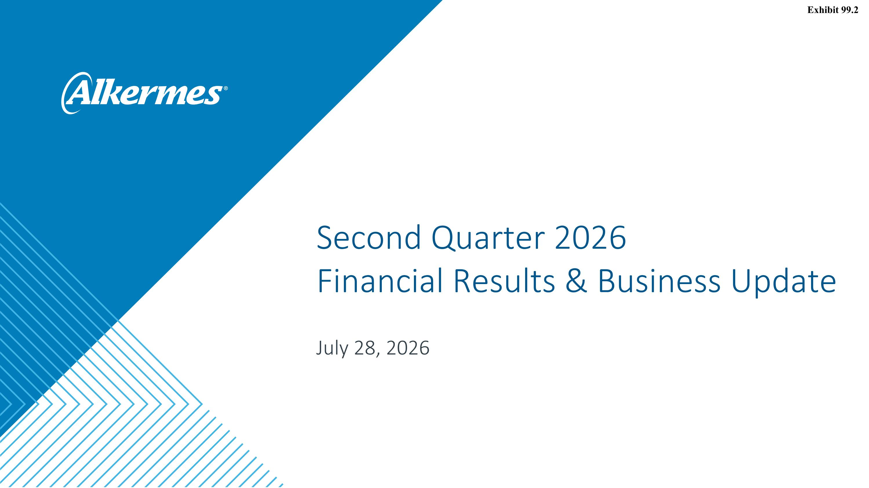
Second Quarter 2026?Financial Results & Business Update July 28, 2026 Exhibit 99.2

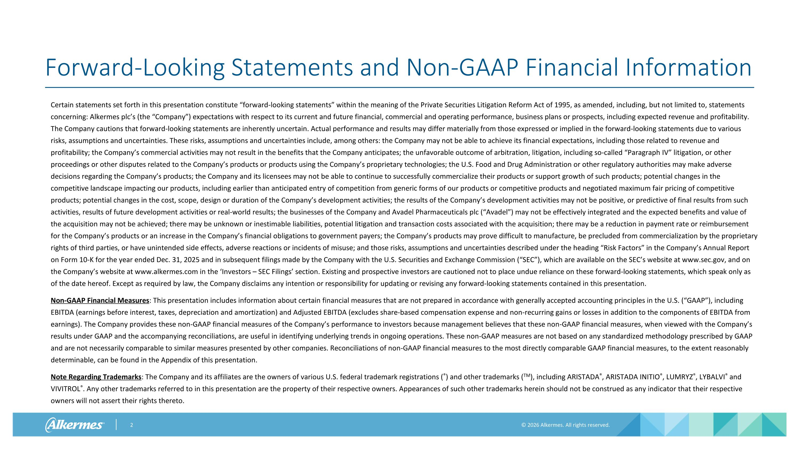
Forward-Looking Statements and Non-GAAP Financial Information Certain statements set forth in this presentation constitute “forward-looking statements” within the meaning of the Private Securities Litigation Reform Act of 1995, as amended, including, but not limited to, statements concerning: Alkermes plc’s (the “Company”) expectations with respect to its current and future financial, commercial and operating performance, business plans or prospects, including expected revenue and profitability. The Company cautions that forward-looking statements are inherently uncertain. Actual performance and results may differ materially from those expressed or implied in the forward-looking statements due to various risks, assumptions and uncertainties. These risks, assumptions and uncertainties include, among others: the Company may not be able to achieve its financial expectations, including those related to revenue and profitability; the Company’s commercial activities may not result in the benefits that the Company anticipates; the unfavorable outcome of arbitration, litigation, including so-called “Paragraph IV” litigation, or other proceedings or other disputes related to the Company’s products or products using the Company’s proprietary technologies; the U.S. Food and Drug Administration or other regulatory authorities may make adverse decisions regarding the Company’s products; the Company and its licensees may not be able to continue to successfully commercialize their products or support growth of such products; potential changes in the competitive landscape impacting our products, including earlier than anticipated entry of competition from generic forms of our products or competitive products and negotiated maximum fair pricing of competitive products; potential changes in the cost, scope, design or duration of the Company’s development activities; the results of the Company’s development activities may not be positive, or predictive of final results from such activities, results of future development activities or real-world results; the businesses of the Company and Avadel Pharmaceuticals plc (“Avadel”) may not be effectively integrated and the expected benefits and value of the acquisition may not be achieved; there may be unknown or inestimable liabilities, potential litigation and transaction costs associated with the acquisition; there may be a reduction in payment rate or reimbursement for the Company’s products or an increase in the Company’s financial obligations to government payers; the Company’s products may prove difficult to manufacture, be precluded from commercialization by the proprietary rights of third parties, or have unintended side effects, adverse reactions or incidents of misuse; and those risks, assumptions and uncertainties described under the heading “Risk Factors” in the Company’s Annual Report on Form 10-K for the year ended Dec. 31, 2025 and in subsequent filings made by the Company with the U.S. Securities and Exchange Commission (“SEC”), which are available on the SEC’s website at www.sec.gov, and on the Company’s website at www.alkermes.com in the ‘Investors – SEC Filings’ section. Existing and prospective investors are cautioned not to place undue reliance on these forward-looking statements, which speak only as of the date hereof. Except as required by law, the Company disclaims any intention or responsibility for updating or revising any forward-looking statements contained in this presentation. Non-GAAP Financial Measures: This presentation includes information about certain financial measures that are not prepared in accordance with generally accepted accounting principles in the U.S. (“GAAP”), including EBITDA (earnings before interest, taxes, depreciation and amortization) and Adjusted EBITDA (excludes share‐based compensation expense and non‐recurring gains or losses in addition to the components of EBITDA from earnings). The Company provides these non-GAAP financial measures of the Company’s performance to investors because management believes that these non-GAAP financial measures, when viewed with the Company’s results under GAAP and the accompanying reconciliations, are useful in identifying underlying trends in ongoing operations. These non-GAAP measures are not based on any standardized methodology prescribed by GAAP and are not necessarily comparable to similar measures presented by other companies. Reconciliations of non-GAAP financial measures to the most directly comparable GAAP financial measures, to the extent reasonably determinable, can be found in the Appendix of this presentation. Note Regarding Trademarks: The Company and its affiliates are the owners of various U.S. federal trademark registrations (®) and other trademarks (TM), including ARISTADA®, ARISTADA INITIO®, LUMRYZ®, LYBALVI® and VIVITROL®. Any other trademarks referred to in this presentation are the property of their respective owners. Appearances of such other trademarks herein should not be construed as any indicator that their respective owners will not assert their rights thereto.

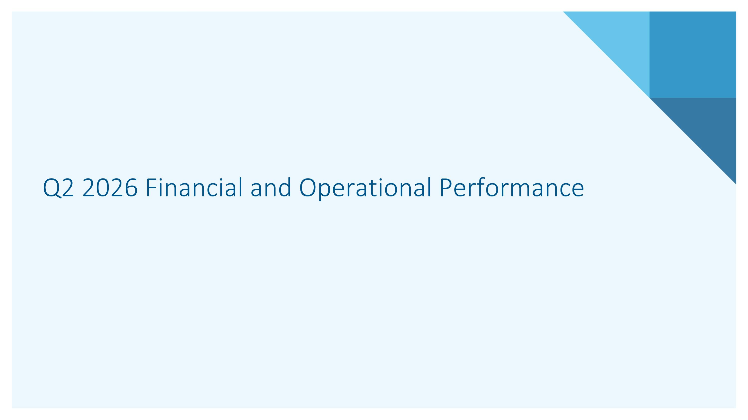
Q2 2026 Financial and Operational Performance

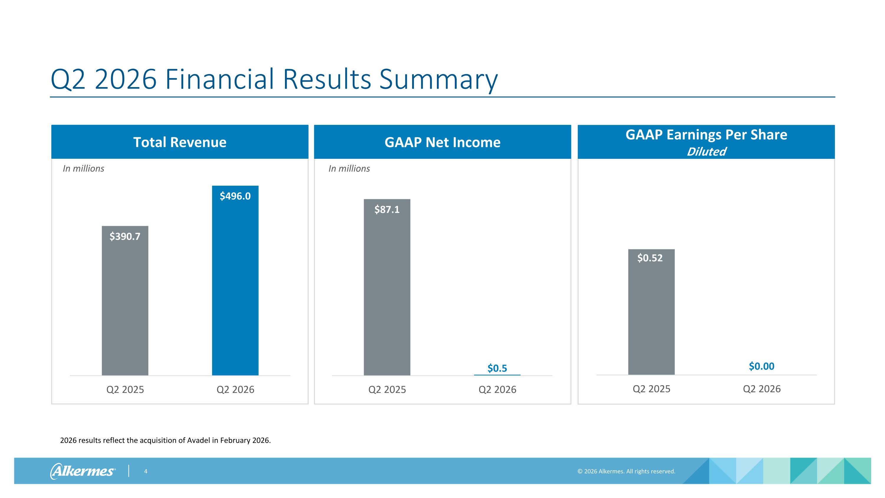
In millions Q2 2026 Financial Results Summary Total Revenue In millions GAAP Net Income GAAP Earnings Per Share ?Diluted 2026 results reflect the acquisition of Avadel in February 2026.

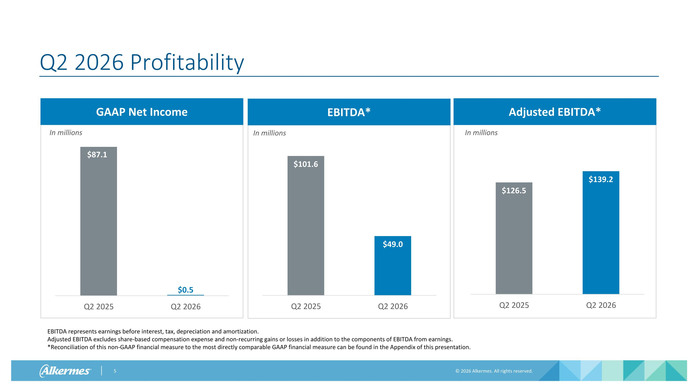
In millions Q2 2026 Profitability GAAP Net Income In millions Adjusted EBITDA* EBITDA* In millions EBITDA represents earnings before interest, tax, depreciation and amortization. Adjusted EBITDA excludes share‐based compensation expense and non‐recurring gains or losses in addition to the components of EBITDA from earnings.?*Reconciliation of this non-GAAP financial measure to the most directly comparable GAAP financial measure can be found in the Appendix of this presentation.

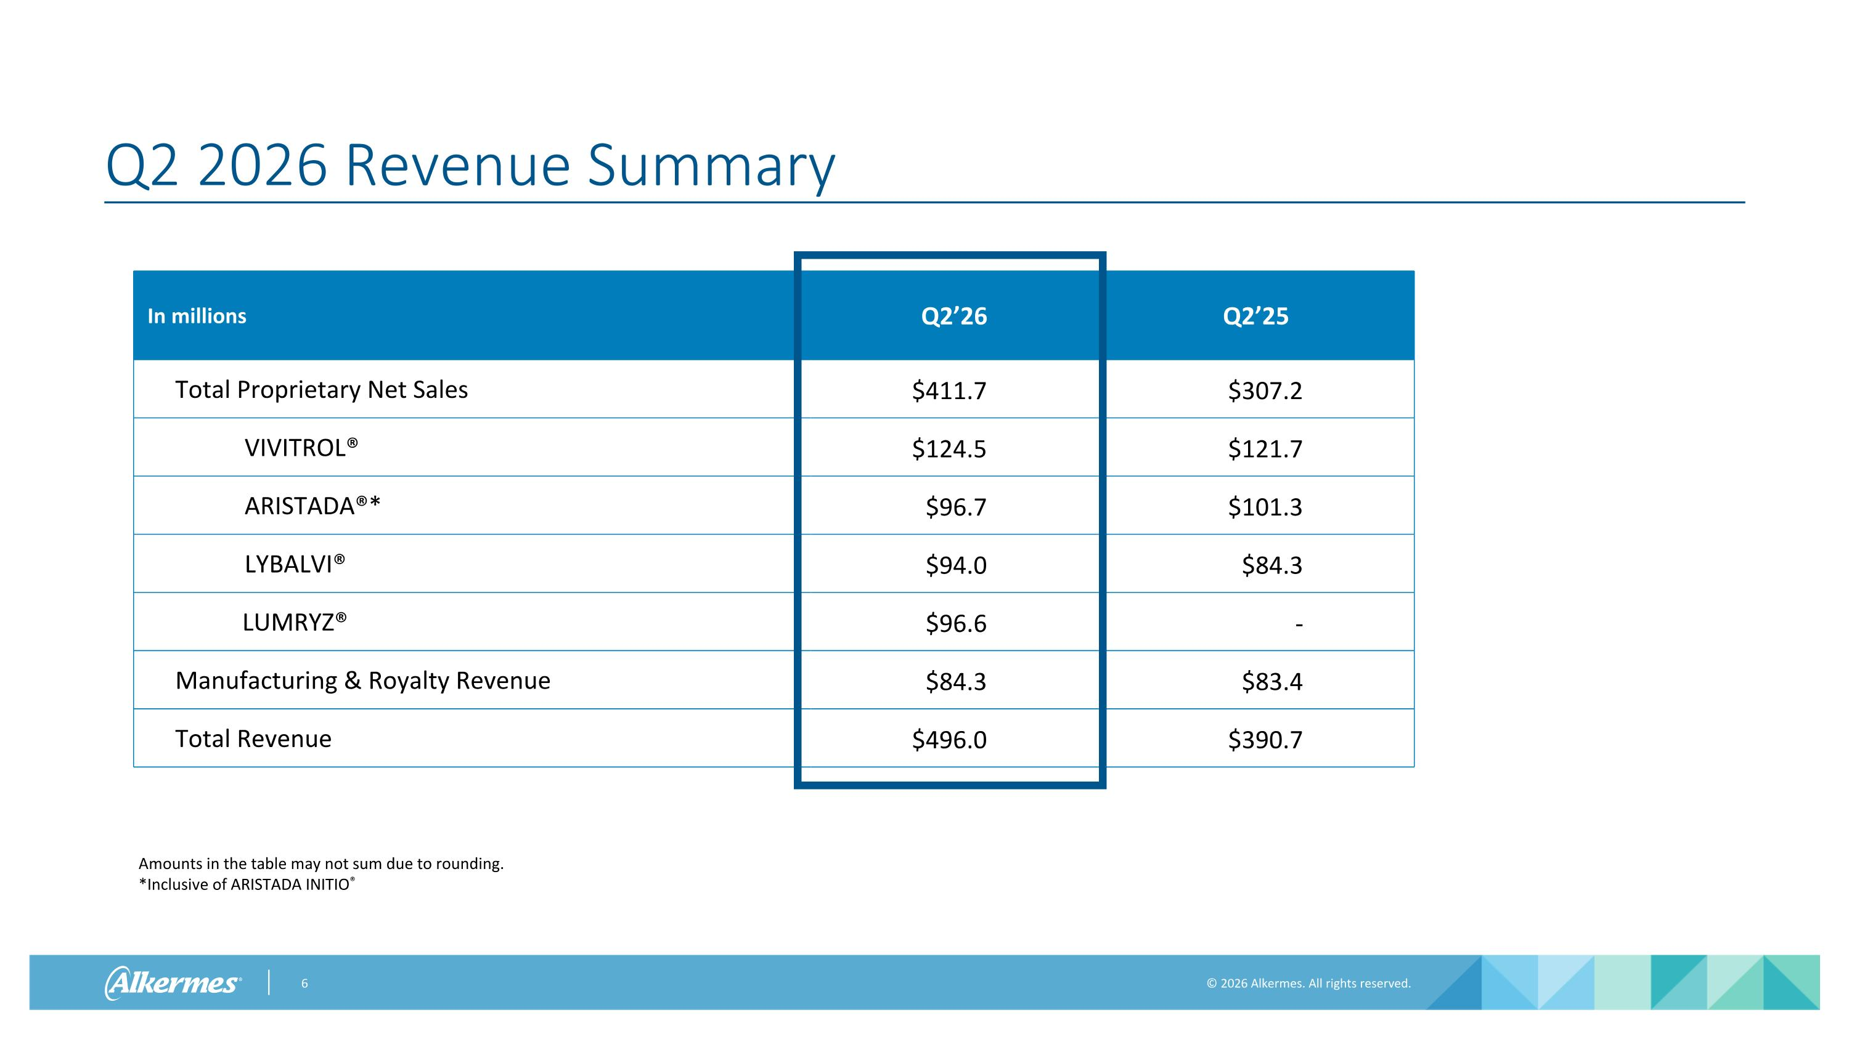
Q2 2026 Revenue Summary In millions Q2’26 Q2’25 Total Proprietary Net Sales $411.7 $307.2 VIVITROL® $124.5 $121.7 ARISTADA®* $96.7 $101.3 LYBALVI® $94.0 $84.3 LUMRYZ® $96.6 - Manufacturing & Royalty Revenue $84.3 $83.4 Total Revenue $496.0 $390.7 Amounts in the table may not sum due to rounding. *Inclusive of ARISTADA INITIO®

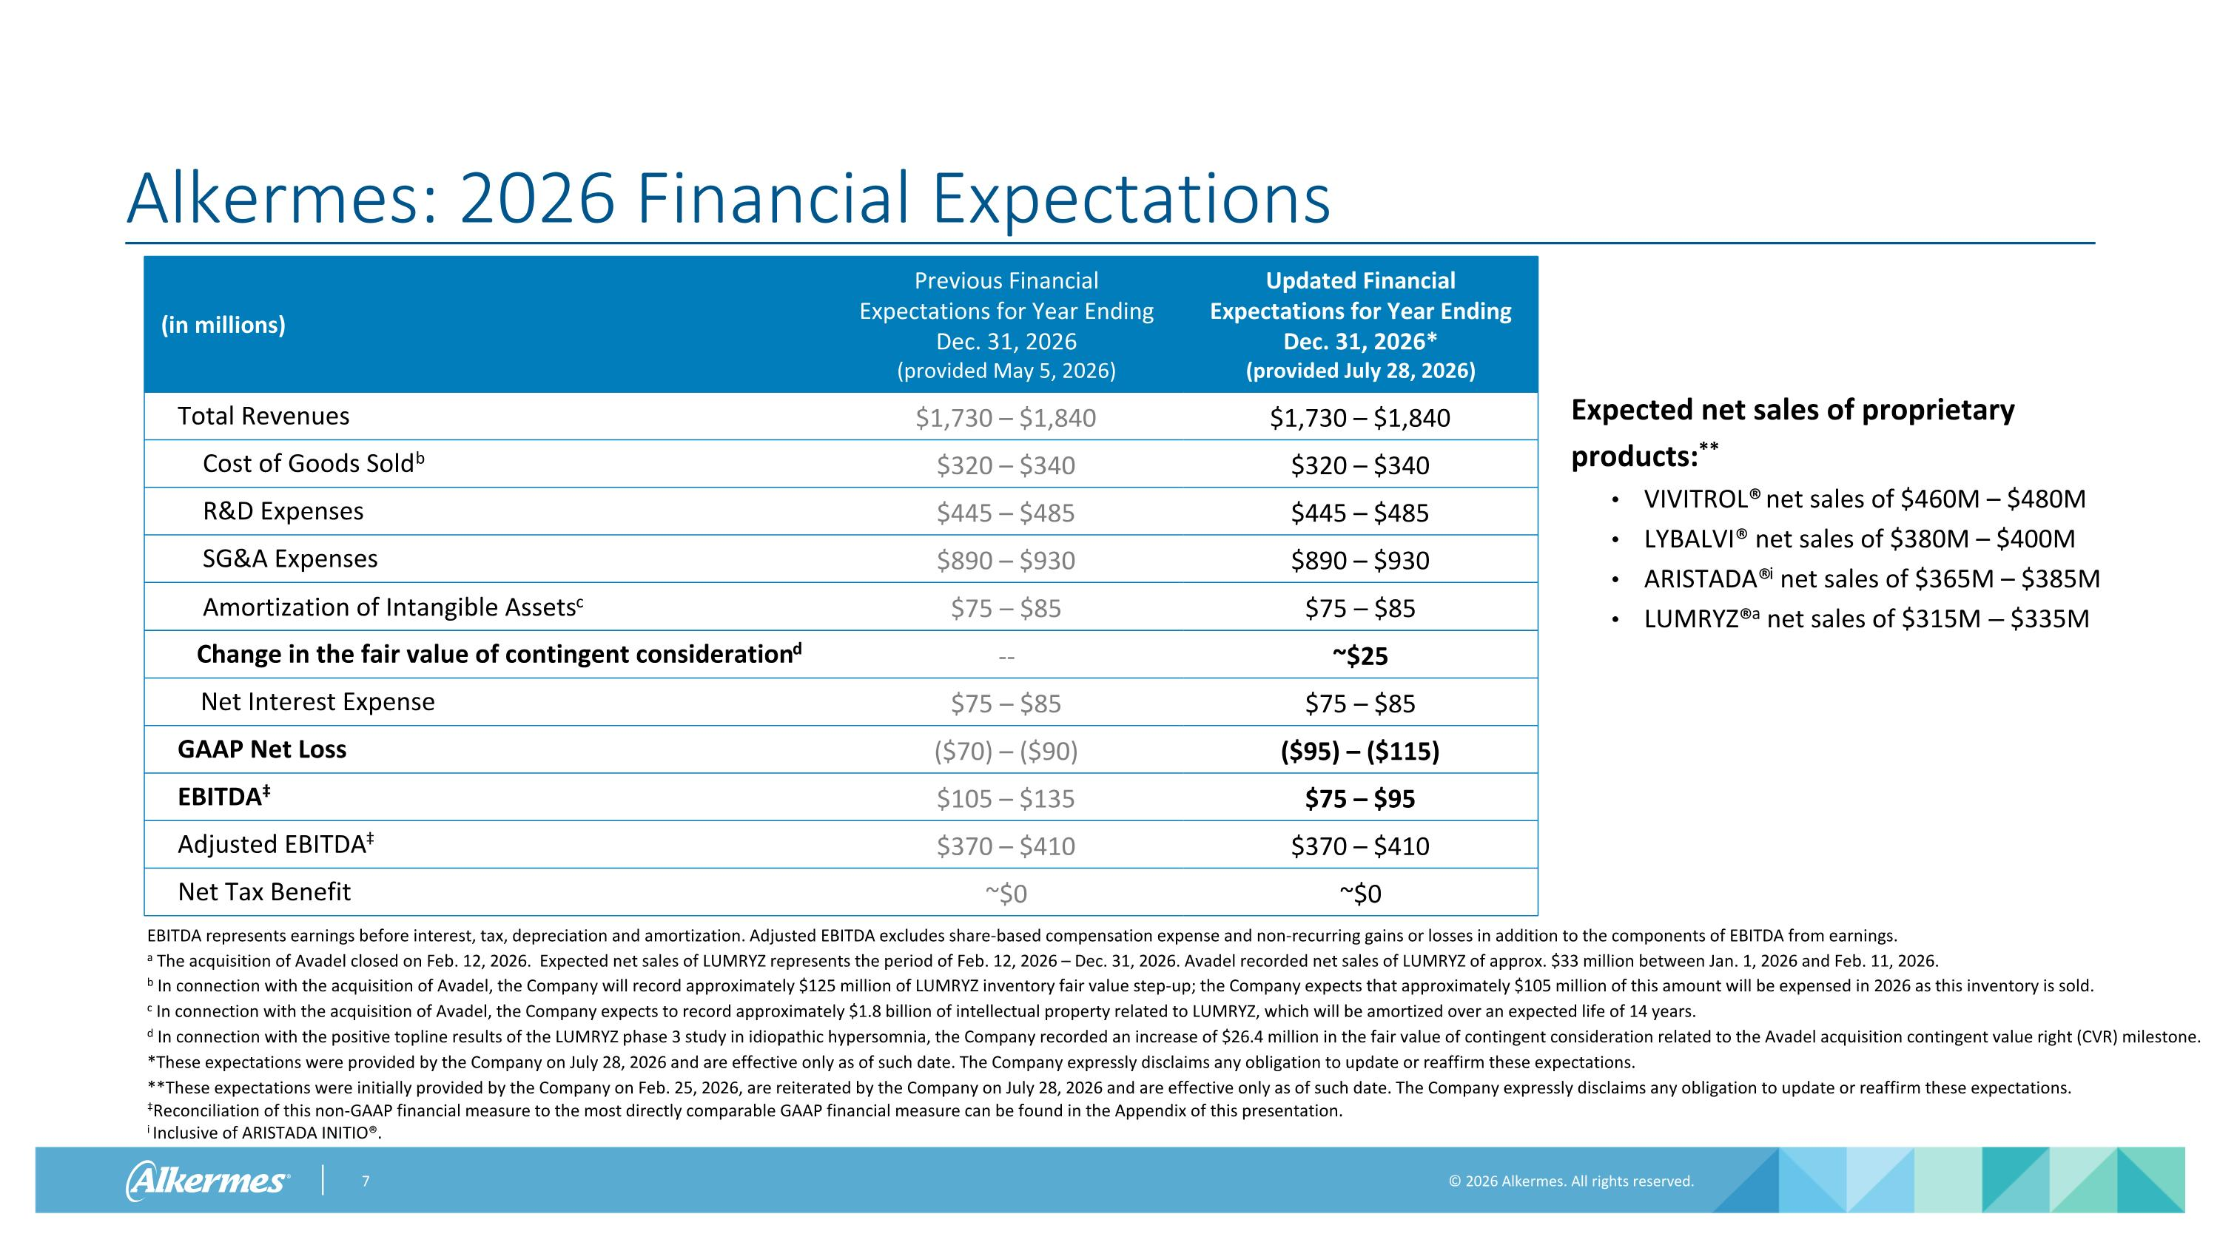
Alkermes: 2026 Financial Expectations a The acquisition of Avadel closed on Feb. 12, 2026. Expected net sales of LUMRYZ represents the period of Feb. 12, 2026 – Dec. 31, 2026. Avadel recorded net sales of LUMRYZ of approx. $33 million between Jan. 1, 2026 and Feb. 11, 2026. b In connection with the acquisition of Avadel, the Company will record approximately $125 million of LUMRYZ inventory fair value step-up; the Company expects that approximately $105 million of this amount will be expensed in 2026 as this inventory is sold. c In connection with the acquisition of Avadel, the Company expects to record approximately $1.8 billion of intellectual property related to LUMRYZ, which will be amortized over an expected life of 14 years. d In connection with the positive topline results of the LUMRYZ phase 3 study in idiopathic hypersomnia, the Company recorded an increase of $26.4 million in the fair value of contingent consideration related to the Avadel acquisition contingent value right (CVR) milestone. *These expectations were provided by the Company on July 28, 2026 and are effective only as of such date. The Company expressly disclaims any obligation to update or reaffirm these expectations. **These expectations were initially provided by the Company on Feb. 25, 2026, are reiterated by the Company on July 28, 2026 and are effective only as of such date. The Company expressly disclaims any obligation to update or reaffirm these expectations. Reconciliation of this non-GAAP financial measure to the most directly comparable GAAP financial measure can be found in the Appendix of this presentation. i Inclusive of ARISTADA INITIO®. (in millions) Previous Financial Expectations for Year Ending Dec. 31, 2026 (provided May 5, 2026) Updated Financial Expectations for Year Ending Dec. 31, 2026* (provided July 28, 2026) Total Revenues $1,730 – $1,840 $1,730 – $1,840 Cost of Goods Soldb $320 – $340 $320 – $340 R&D Expenses $445 – $485 $445 – $485 SG&A Expenses $890 – $930 $890 – $930 Amortization of Intangible Assetsc $75 – $85 $75 – $85 Change in the fair value of contingent considerationd -- ~$25 Net Interest Expense $75 – $85 $75 – $85 GAAP Net Loss ($70) – ($90) ($95) – ($115) EBITDA $105 – $135 $75 – $95 Adjusted EBITDA $370 – $410 $370 – $410 Net Tax Benefit ~$0 ~$0 Expected net sales of proprietary products:** VIVITROL® net sales of $460M – $480M LYBALVI® net sales of $380M – $400M ARISTADA®i net sales of $365M – $385M LUMRYZ®a net sales of $315M – $335M EBITDA represents earnings before interest, tax, depreciation and amortization. Adjusted EBITDA excludes share‐based compensation expense and non‐recurring gains or losses in addition to the components of EBITDA from earnings.

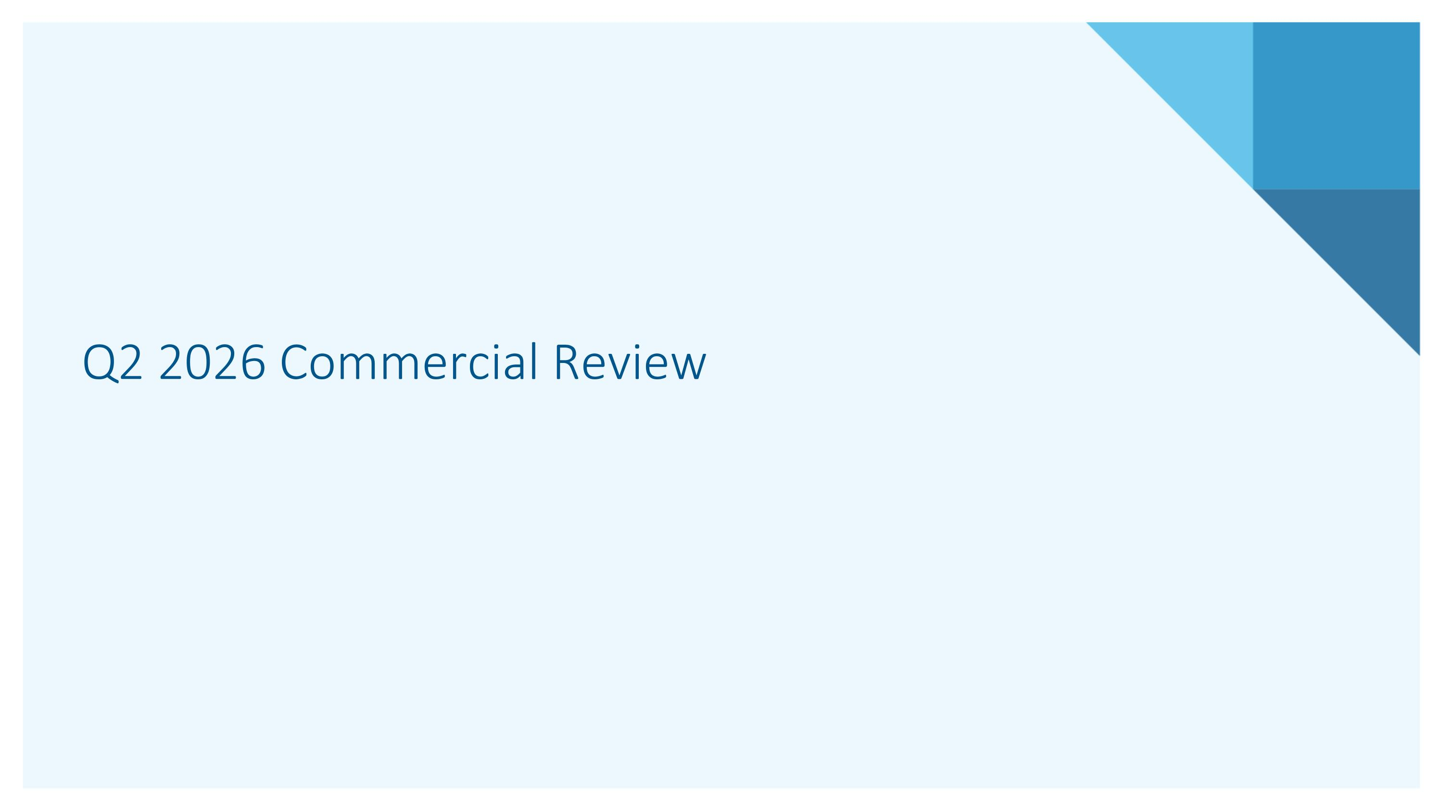
Q2 2026 Commercial Review

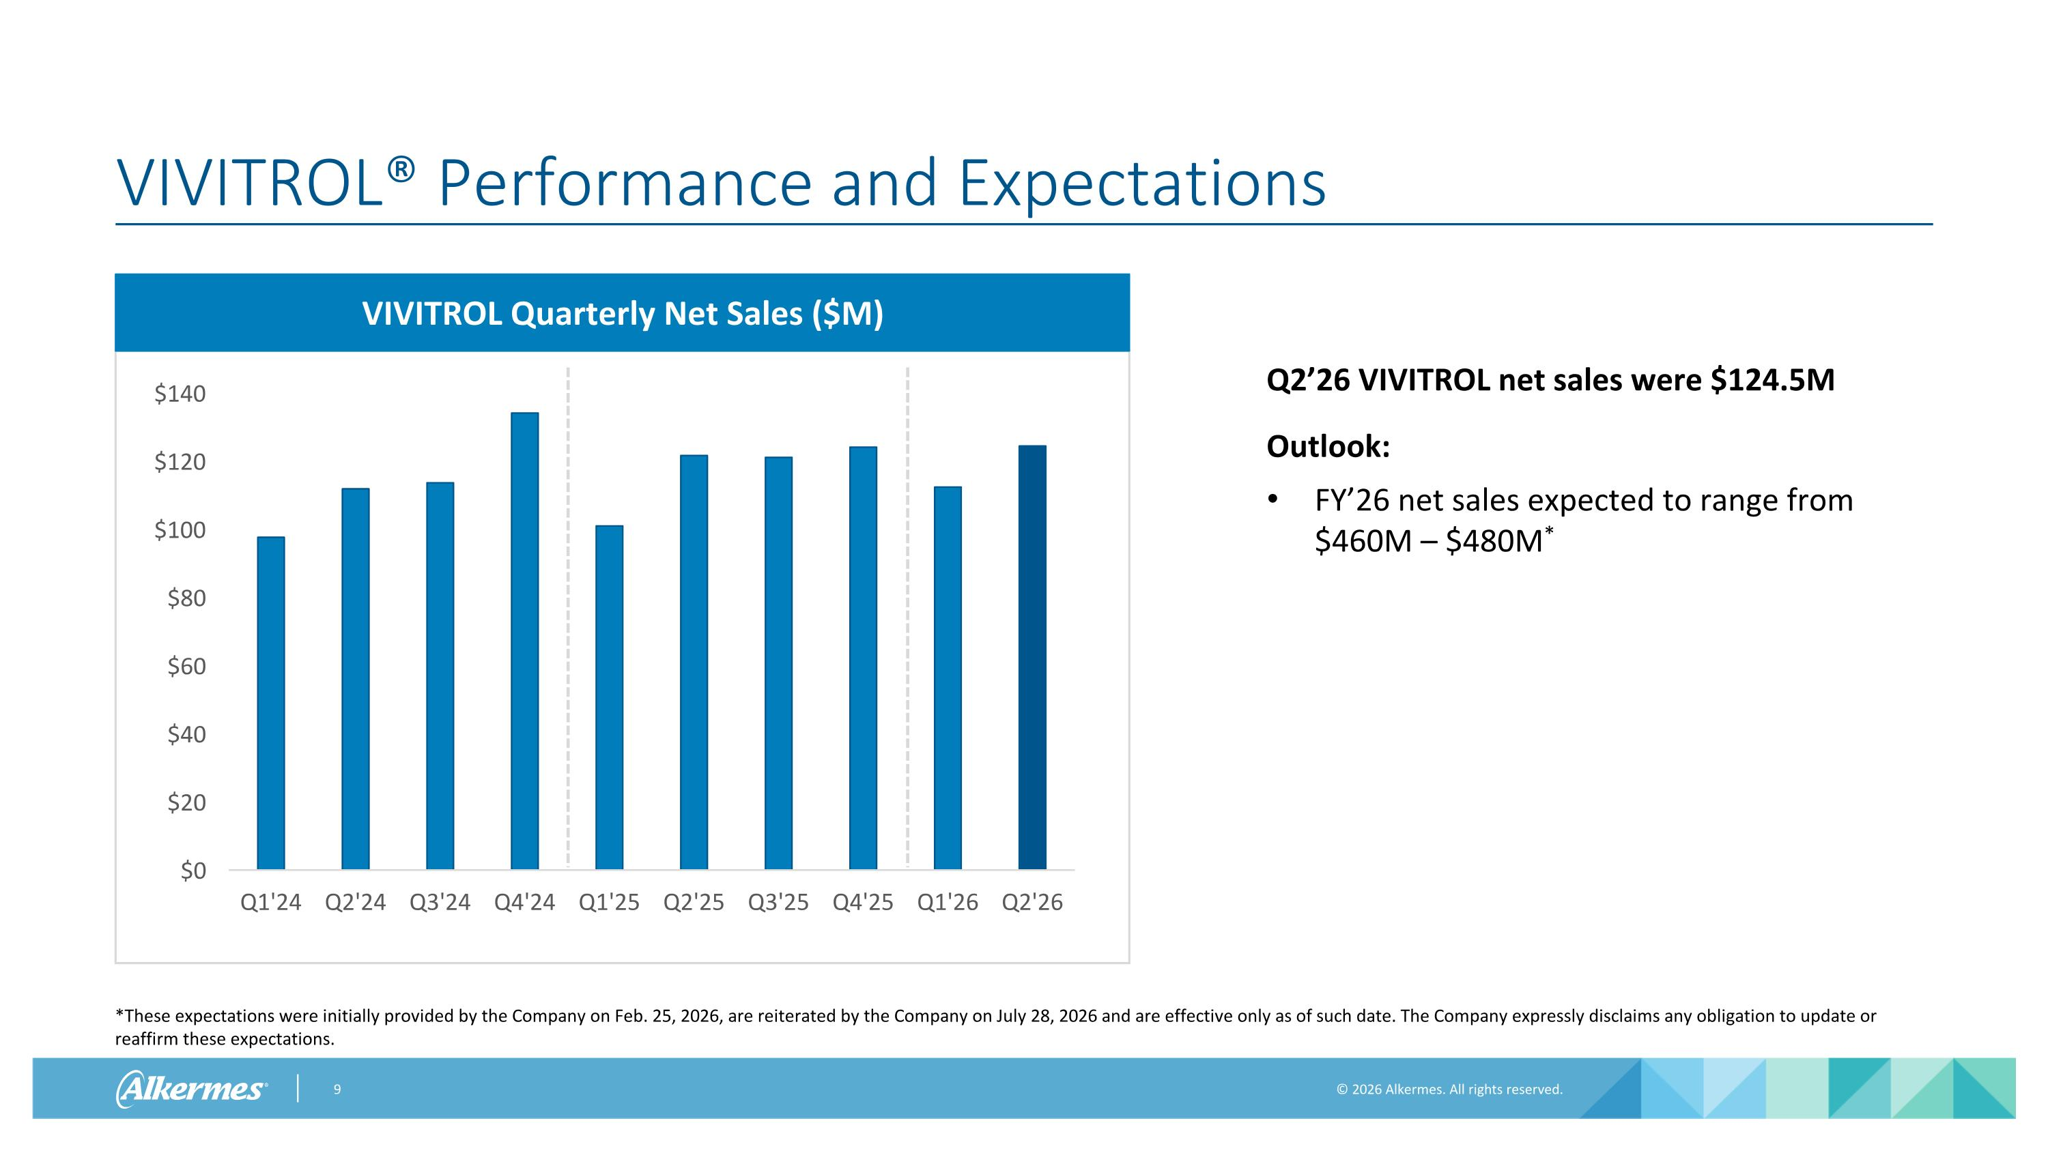
VIVITROL® Performance and Expectations *These expectations were initially provided by the Company on Feb. 25, 2026, are reiterated by the Company on July 28, 2026 and are effective only as of such date. The Company expressly disclaims any obligation to update or reaffirm these expectations. Q2’26 VIVITROL net sales were $124.5M Outlook: FY’26 net sales expected to range from $460M – $480M* VIVITROL Quarterly Net Sales ($M)

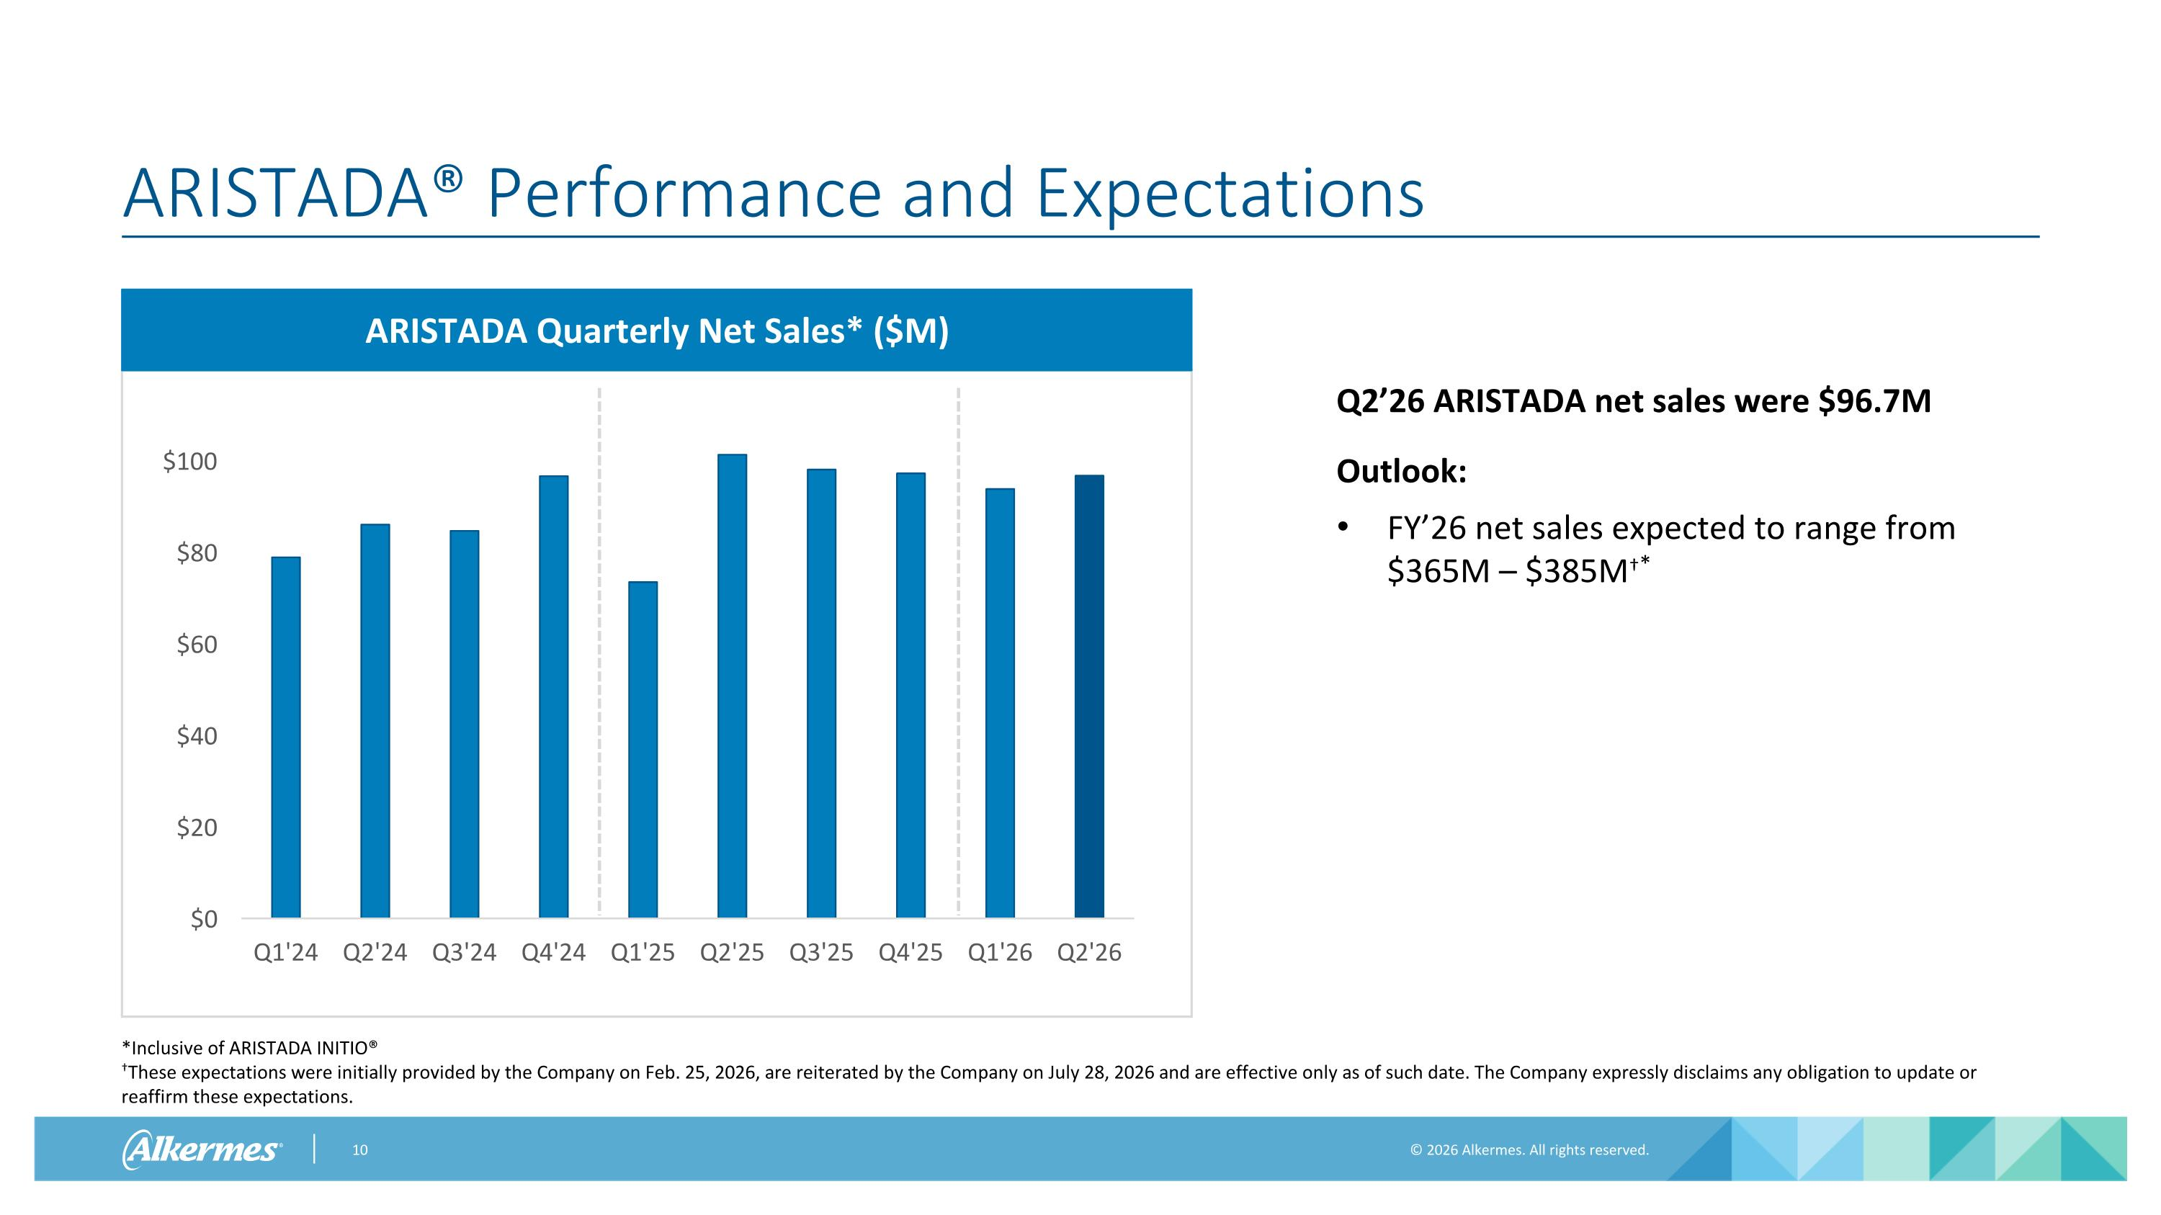
ARISTADA® Performance and Expectations Q2’26 ARISTADA net sales were $96.7M Outlook: FY’26 net sales expected to range from $365M – $385M* *Inclusive of ARISTADA INITIO®?These expectations were initially provided by the Company on Feb. 25, 2026, are reiterated by the Company on July 28, 2026 and are effective only as of such date. The Company expressly disclaims any obligation to update or reaffirm these expectations. ARISTADA Quarterly Net Sales* ($M)

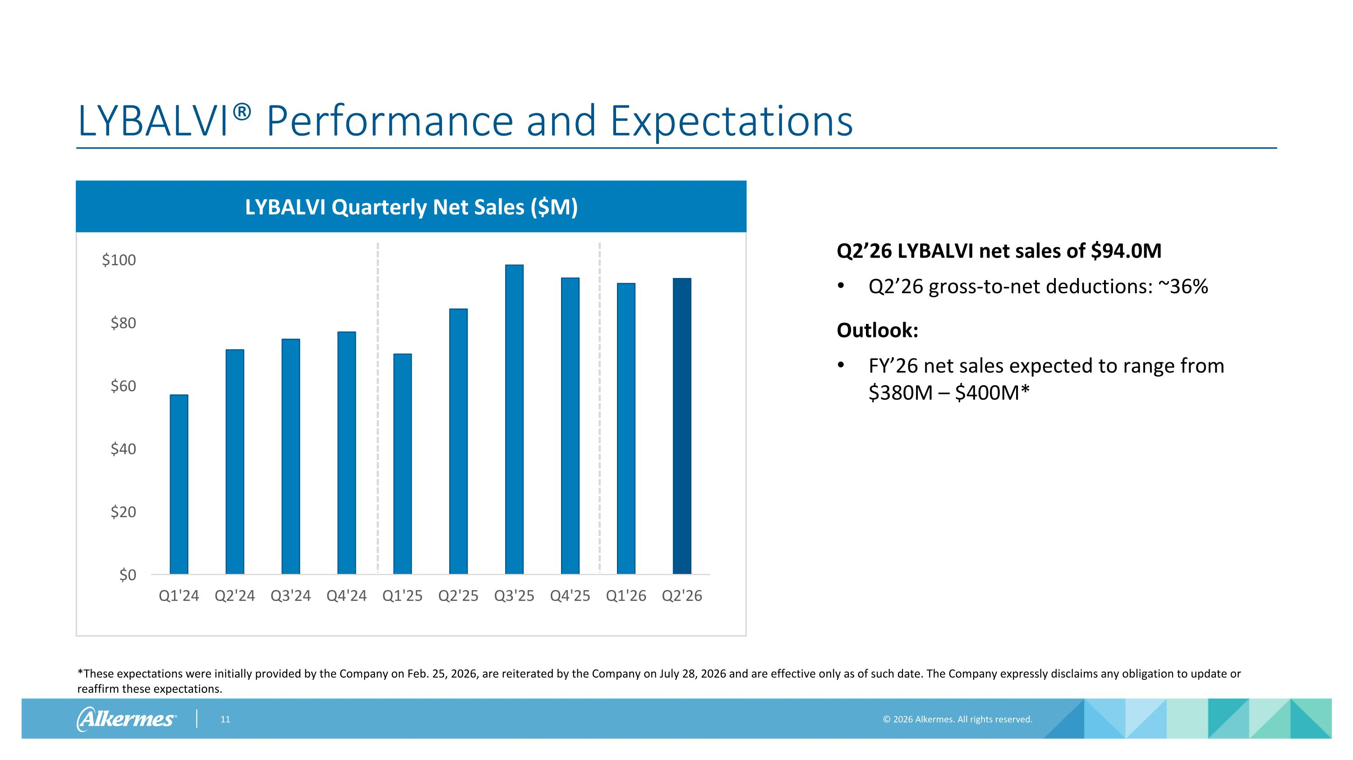
LYBALVI® Performance and Expectations *These expectations were initially provided by the Company on Feb. 25, 2026, are reiterated by the Company on July 28, 2026 and are effective only as of such date. The Company expressly disclaims any obligation to update or reaffirm these expectations. Q2’26 LYBALVI net sales of $94.0M Q2’26 gross-to-net deductions: ~36% Outlook: FY’26 net sales expected to range from $380M – $400M* LYBALVI Quarterly Net Sales ($M)

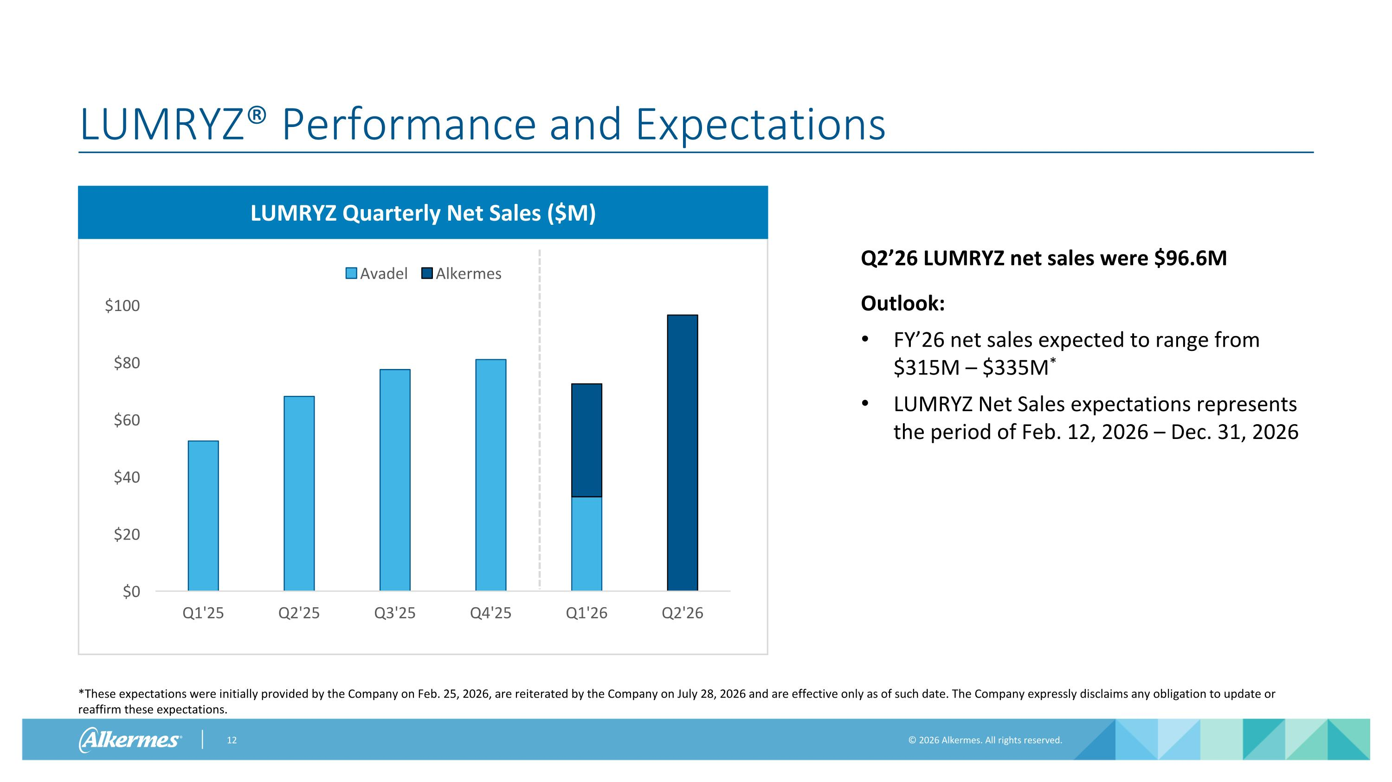
LUMRYZ® Performance and Expectations *These expectations were initially provided by the Company on Feb. 25, 2026, are reiterated by the Company on July 28, 2026 and are effective only as of such date. The Company expressly disclaims any obligation to update or reaffirm these expectations. Q2’26 LUMRYZ net sales were $96.6M Outlook: FY’26 net sales expected to range from $315M – $335M* LUMRYZ Net Sales expectations represents the period of Feb. 12, 2026 – Dec. 31, 2026 LUMRYZ Quarterly Net Sales ($M)


Appendix

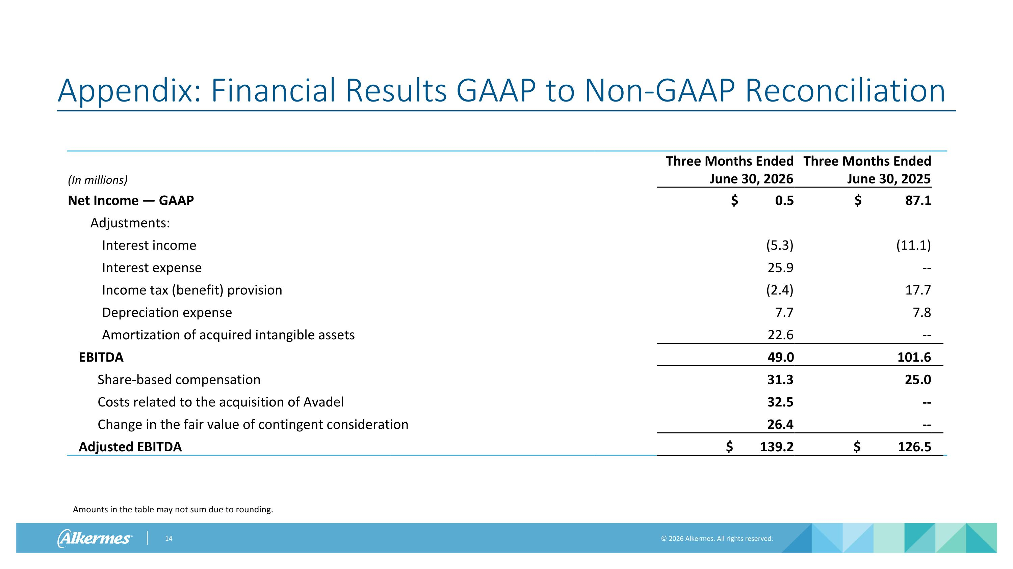
Appendix: Financial Results GAAP to Non-GAAP Reconciliation (In millions) Three Months Ended June 30, 2026 Three Months Ended June 30, 2025 Net Income — GAAP $ 0.5 $ 87.1 Adjustments: Interest income (5.3) (11.1) Interest expense 25.9 -- Income tax (benefit) provision (2.4) 17.7 Depreciation expense 7.7 7.8 Amortization of acquired intangible assets 22.6 -- EBITDA 49.0 101.6 Share-based compensation 31.3 25.0 Costs related to the acquisition of Avadel 32.5 -- Change in the fair value of contingent consideration 26.4 -- Adjusted EBITDA $ 139.2 $ 126.5 Amounts in the table may not sum due to rounding.

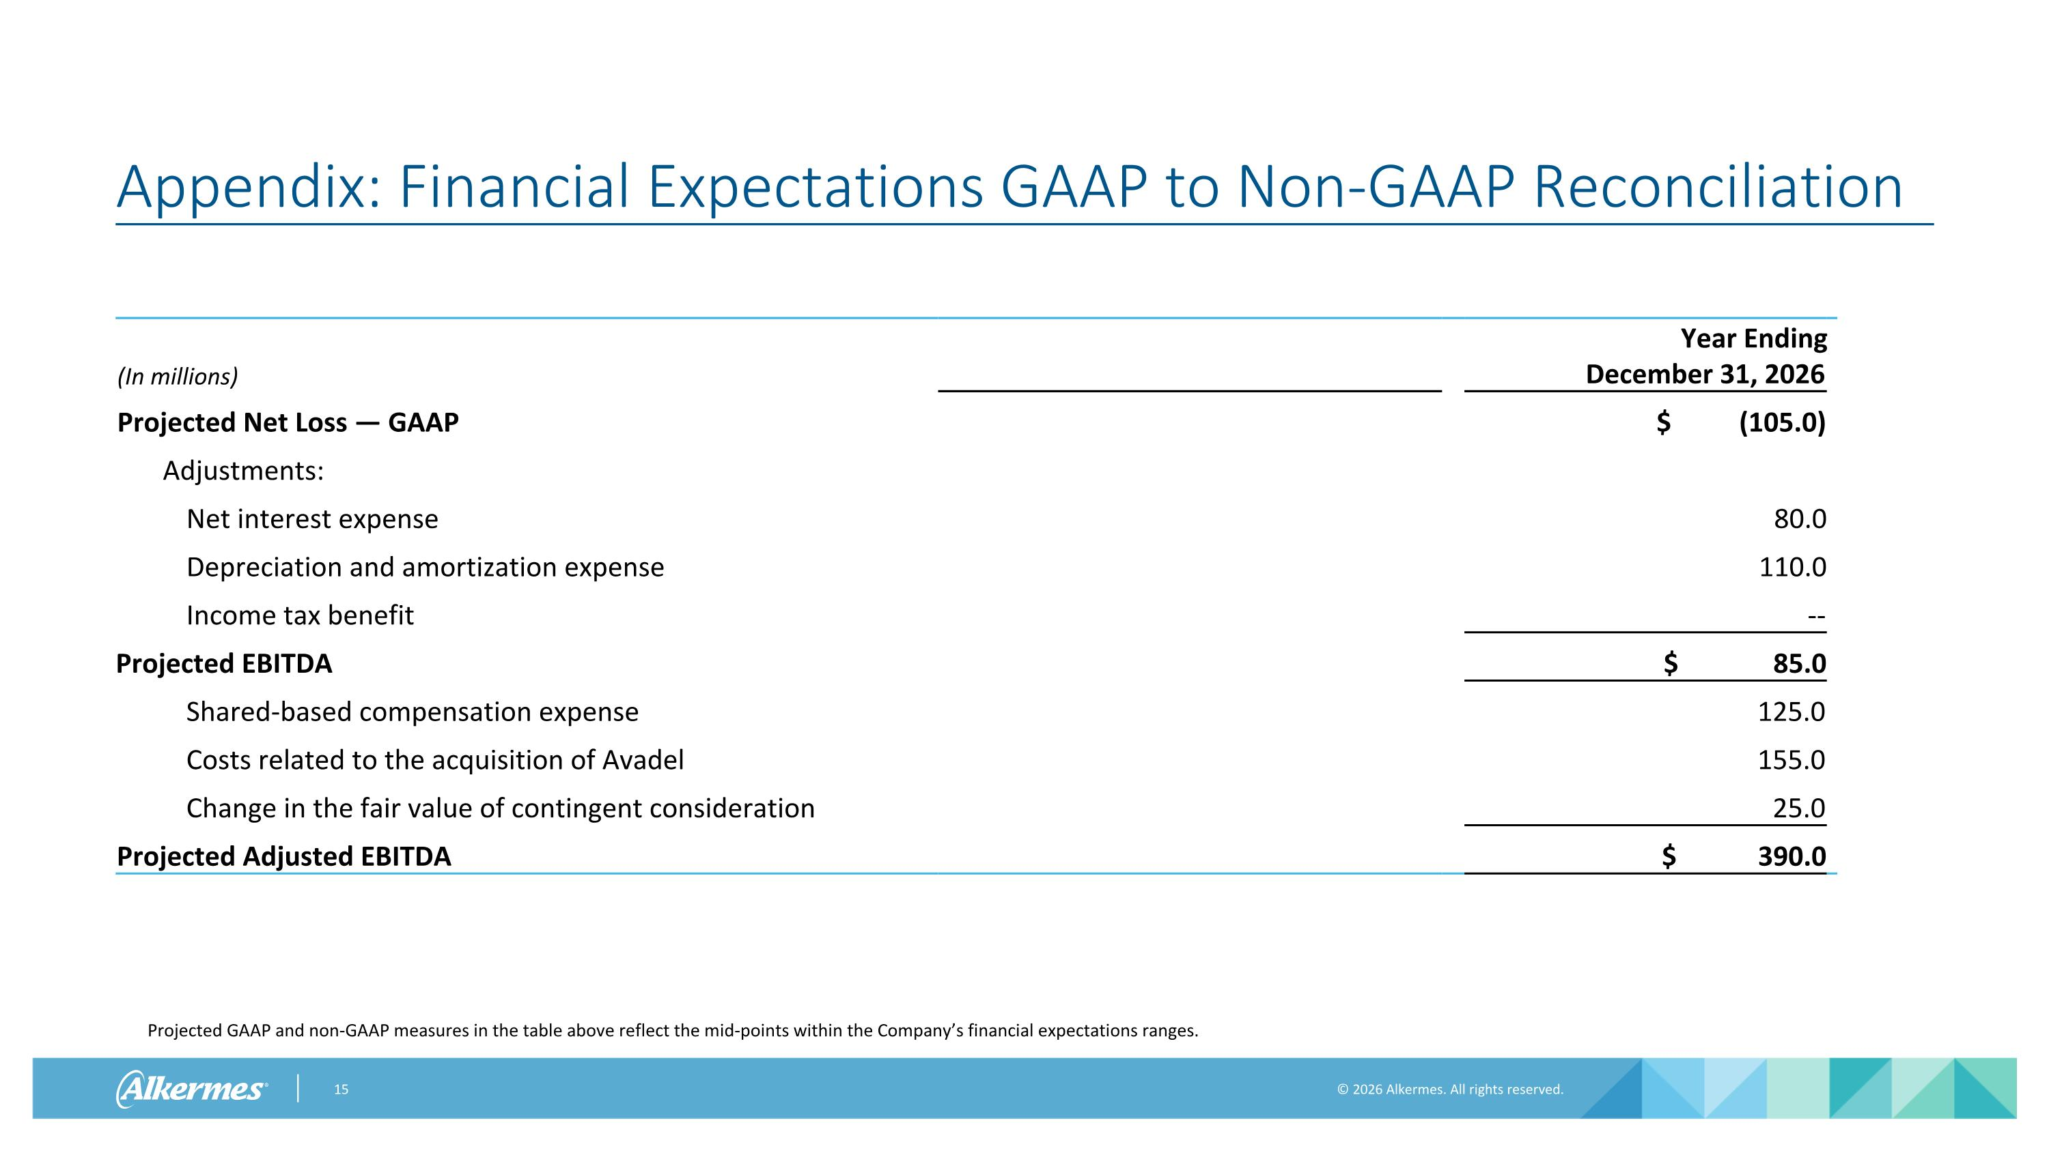
Appendix: Financial Expectations GAAP to Non-GAAP Reconciliation Projected GAAP and non-GAAP measures in the table above reflect the mid-points within the Company’s financial expectations ranges. (In millions) Year Ended December 31, 2023 Year Ending December 31, 2026 Projected Net Loss — GAAP $ (105.0) Adjustments: Net interest expense 80.0 Depreciation and amortization expense 110.0 Income tax benefit -- Projected EBITDA $ 85.0 Shared-based compensation expense 125.0 Costs related to the acquisition of Avadel 155.0 Change in the fair value of contingent consideration 25.0 Projected Adjusted EBITDA $ 390.0


www.alkermes.com

